**Credential Revocation Flow**

1. 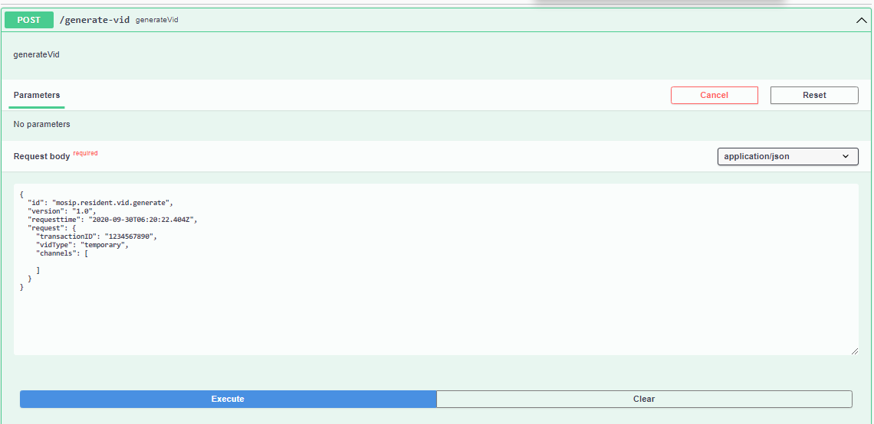Generate a credential.

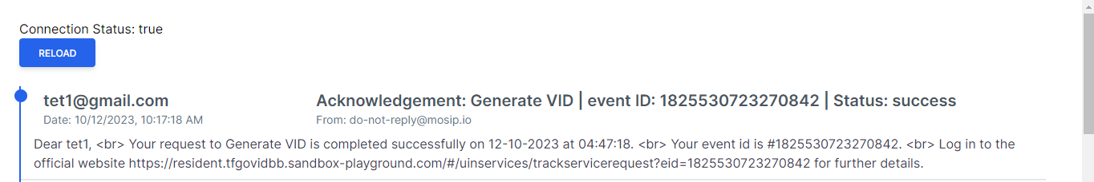Notification

1. 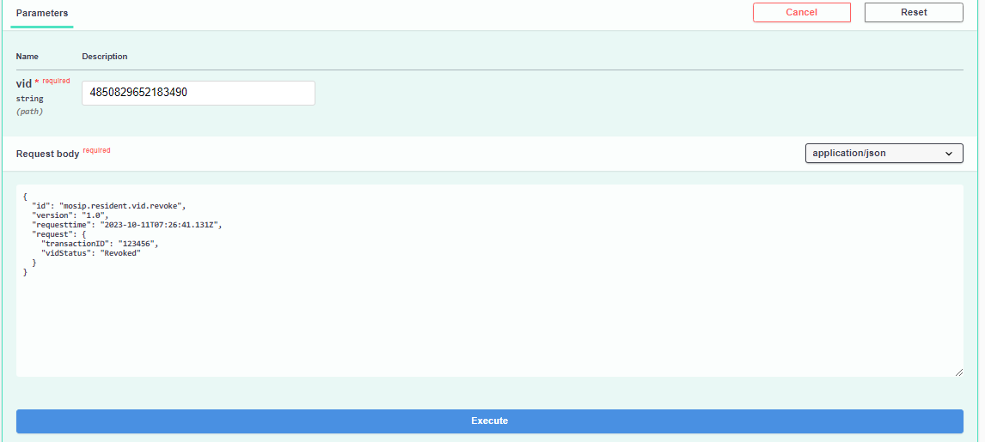Revoke a credential.

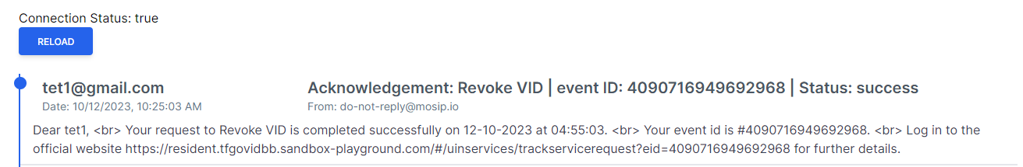Notification

1. 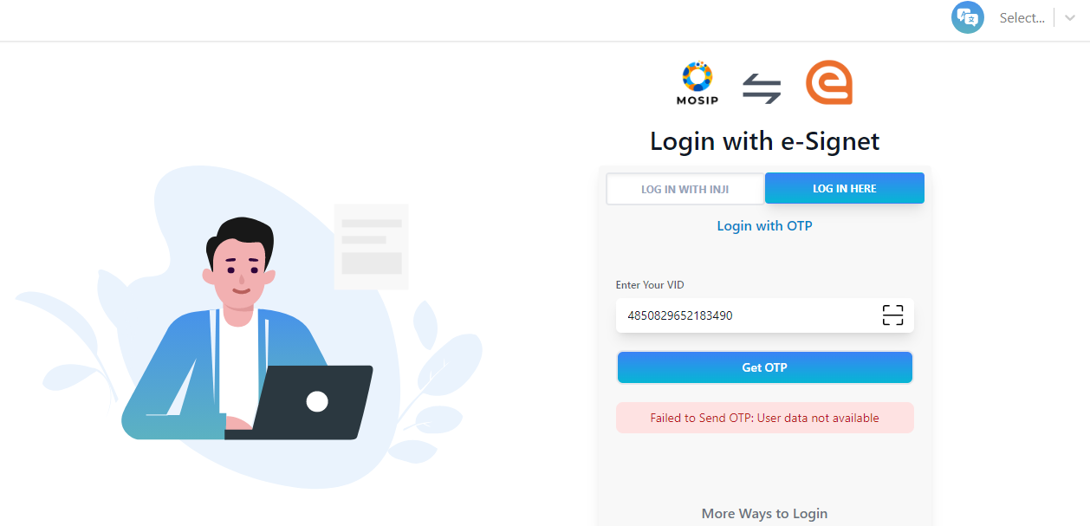Login to resident service portal with revoked credential.